**Guide to Conducting Clinical Research at**

**Baylor St. Luke’s Medical Center**

**Office of Clinical Research**

**Research Administration Office**

***Baylor St. Luke’s Medical Center (BSLMC)***

David H. Berger, M.D.

Senior Vice President, Chief Operating Officer

Mark J. Biscone, PhD, FACHE

Director of Research

***Office of Clinical Research***

***BSLMC Research Office***

***6501 Fannin St., NA332A-B***

Obi Ash

Project Manager

713-798-6074

[Obiajulum.Ashibuogwu@bcm.edu](mailto:Obiajulum.Ashibuogwu@bcm.edu)

Angie Esquivel

Lead Project Coordinator

713-798-6064

[aresquiv@bcm.edu](mailto:aresquiv@bcm.edu)

Table of Contents

*Ctrl+Click on the page number to jump to a page*

Introduction to Clinical Research at Baylor St. Luke’s Medical Center 5

Principal Investigator Responsibilities 5

BSLMC Accepted Institutional Review Boards 5

Administrative Review and Approval for Clinical Research at BSLMC 5

The BSLMC Administrative Approval Process 6

Initiation 6

Review 6

Approval 7

After Approval 7

Research Pricing and Financial Agreement 8

Ethical and Religious Directives 9

Patient Care Area In-Services 9

Request for Access to PHI for Research Purposes without Patient Authorization 9

Badging & Credentialing 9

Research Pharmacy 10

Pathology 10

Laboratory Tests 11

Tissue Collection 11

Research Visits 11

Epic Access 11

Scheduling research visits at BSLMC 11

Associating Patient Records and Linking Visit Encounters to Epic Research Records 12

For study teams without Epic access 12

For study teams with Epic access 13

To associate a patient record to a study in Epic 13

To link a specific encounter (visit) to the study in Epic 16

Responsibility for maintaining current research patient status in Epic 18

Associating Patient Records with Research Informed Consent Forms 18

Research Charge Routing and Review 19

Visit charge assignment 19

Charge assignment for coordinators with Epic access 19

Charge assignment for coordinators without Epic access 23

Monthly study account billing 25

BSLMC Clinical Research Center 26

Device Study Impact Analysis 27

Appendix I 28

Instructions to provide view-only protocol access to BSLMC Research Office 28

Appendix II 29

Sample BSLMC Application for Administrative Review 29

Sample Research Financial Agreement 36

Sample Request for Access to PHI for Research Purposes Form 38

Appendix III 41

BSLMC Research Compliance Review – HIPAA Authorization Language 41

List of Required Elements 41

Appendix IV 43

Sample Call Center/Registration Form 43

Appendix V 44

Sample of Request for Clinical Research Center Support 44

Clinical Research Center Study Initiation Workflow 45

Appendix VI 46

Sample Device Impact Assessment Request Form 46

Impact Analysis Workflow 49

Appendix VII 50

BSLMC Epic Study Build 50

# Introduction to Clinical Research at Baylor St. Luke’s Medical Center

Baylor St. Luke’s Medical Center (BSLMC) is home to world-class clinical care and supports top-tier clinical research through its collaborations with academic and private practice investigators. The purpose of this guide is to provide research staff with an overview of services, procedures and requirements for conducting clinical research at BSLMC.

## Principal Investigator Responsibilities

Prior to enrolling participants in any research project conducted at BSLMC, it is the responsibility of the Principal Investigator to obtain both:

(1) IRB approval from a BSLMC-accepted IRB, and

(2) Administrative approval from the BSLMC Research Office

## BSLMC Accepted Institutional Review Boards

* Baylor College of Medicine (BCM)
* Biomedical Research Alliance of New York (BRANY)
* CHI Institute for Research and Innovation (CHIRB)
* University of Texas Health Science Center- Houston
* Western Institutional Review Board (WIRB)
* National Cancer Institute Central IRB (CIRB)
* Chesapeake IRB
* Schulman Associates Institutional Review Board, Inc. (Schulman IRB)

## Administrative Review and Approval for Clinical Research at BSLMC

BSLMC uses an administrative review and approval process to assist with oversight and management of research in BSLMC facilities. Before beginning any research at BSLMC, Principal Investigators must first obtain administrative approval. Approval requires submission of a completed Administrative Application, which is reviewed by all BSLMC areas directly impacted by the study as well as executive leadership. The administrative approval process includes a review of each protocol to ensure patient safety, operational and financial feasibility and hospital compliance.

# The BSLMC Administrative Approval Process

## Initiation

To initiate the BSLMC administrative review and approval process, Investigators must submit a BSLMC Administrative Application. Visit the [BSLMC Research website](http://www.chistlukeshealth.org/conducting-research-at-bslmc)  to obtain the current BSLMC Administrative Application. Application requirements include submission of study documents. You may give BSLMC Research Office view-only access to your IRB submission as shown in *Appendix I*, or you may attach the documents manually to your Administrative Application.

See example Administrative Application in *Appendix II**.*

Supplemental forms are required if your study includes investigational device purchase, access to PHI without subject authorization, or the Clinical Research Center, or if your study is managed by the Catholic Health Initiatives Institute for Research and Innovation. More information on this is below. Sample forms are available in *Appendix II*. Contact the BSLMC Research Office (713-798-6024; [BSLMC_Research@bcm.edu](mailto:BSLMC_Research@bcm.edu)) with questions.

Upon submission of the Administrative Application, the BSLMC Research Office initiates the review and approval process.

## Review

The BSLMC Research Office conducts administrative review of the application, which includes:

* Verifying IRB approval
* Verifying [CITI](https://www.citiprogram.org/) training for research personnel identified on the IRB application. Current training requirements are described on the administrative application.
* Verifying BSLMC credentialing for the principal investigator (see *Badging and Credentialing*, below).
* Providing research pricing and executing a financial agreement for research procedures conducted at BSLMC. See next section, *Research Pricing and Financial Agreement*, for more information.
* Obtaining approval from hospital areas affected by the study, as indicated in the Administrative Application.
* Obtaining approval from any BSLMC special committees that may apply (i.e. Radiation Safety).
* Routing drug studies to the BSLMC research pharmacy for review.
* For device studies, routing device purchase agreements and related documents for BSLMC review, verifying CMS coverage and obtaining charge codes. See *Device Study Impact Analysis* for more information on this process.
* Ensuring study teams conduct in-services for BSLMC staff in areas utilized by the study. See *Patient Care In-Services*, below.
* Conducting a Catholic Health Initiatives compliance review to ensure compliance with HIPAA authorization requirements and conflict of interest disclosure, check for debarment of investigators, and verify regulatory committee approvals and compliance with CHI national policies. See *Appendix III* for sample review template and description.

## Approval

The Research Office works with the Principal Investigator and study team to clarify any logistical, financial or regulatory issues. Following completion of administrative review, the Research Office routes the application for BSLMC executive review. The BSLMC Research Office will notify study teams of approval/disapproval.

## After Approval

Once a study receives administrative approval, the BSLMC Research Office creates a study-specific record in Epic. This record is associated with patient encounters to allow billing to the study account. See *Appendix VII*for details of information entered into the Epic study record.

In addition, the BSLMC Research Office adds the approved study to the BSLMC public clinical study recruitment website. The searchable website is accessible to the public through the BSLMC research website and serves as a recruitment aid for trials conducted at BSLMC.

Renewal of administrative approval is not required. However, study teams should notify the BSLMC Research Office of changes that may impact BSLMC. This includes changes in study status, modifications to visit procedures that may affect billing, and principal investigator changes.

Reference: BSLMC Policy & Procedure, *Protocol Administrative Review*.

## Research Pricing and Financial Agreement

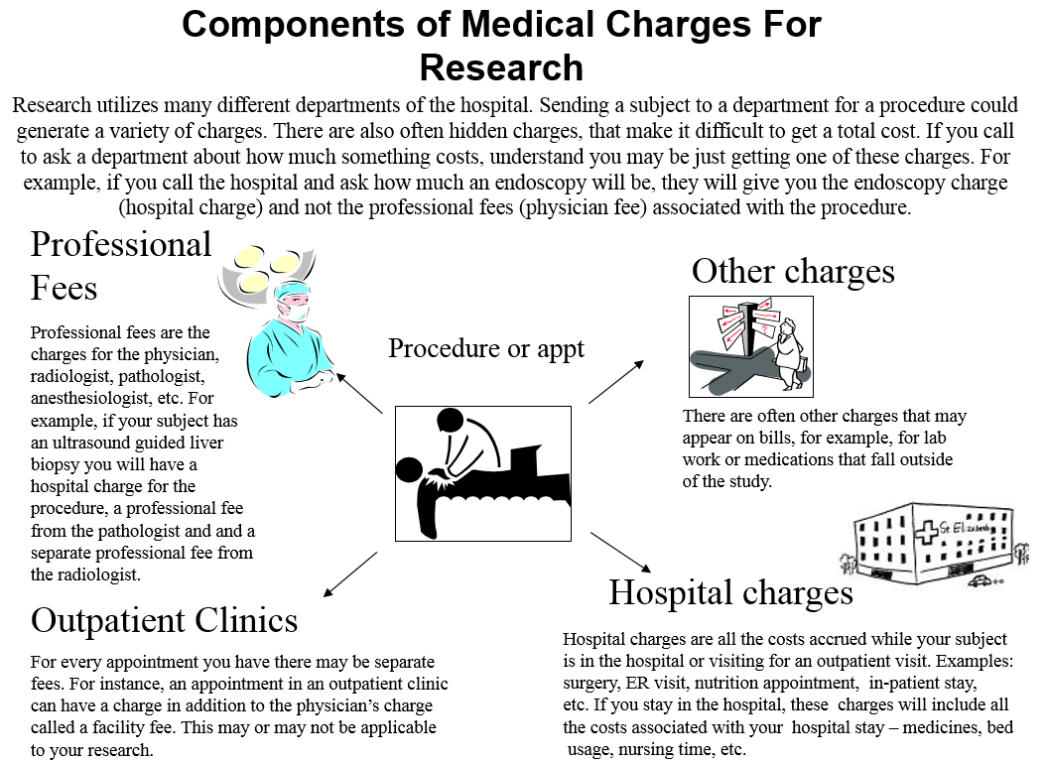

BSLMC provides discounted hospital pricing for research procedures and tests. The BSLMC Research Office coordinates with BSLMC Finance to obtain a study-specific research pricing based on the schedule of events provided by the study team in the Administrative Application. Study teams may contact the BSLMC Research Office at any time for assistance with BSLMC pricing for study feasibility or budget preparation purposes.

To ensure complete and accurate pricing, the study schedule of events submitted with the administrative application must clearly delineate each procedure as billable as conventional care or research and include CPT and ICD-10 codes for outpatient and inpatient procedures, as applicable. Approved pricing is integrated into a study-specific Financial Agreement that requires principal investigator signature. The Agreement itemizes the research pricing for any protocol-required tests/items covered by the sponsor. See example Financial Agreement in *Appendix II**.*

Although not required for administrative approval, study teams are responsible for completing the Medicare-required Qualifying Clinical Trial coverage analysis before study initiation and providing upon request to the BSLMC Research Office.

Please note: Professional fees are supplied by outside providers and their fees are billed separately from the hospital charges. The BSLMC Research Office can provide the study team with contact information for research price negotiations with hospital-contracted professional providers.

BSLMC Patient Financial Services utilizes the pricing provided in the Financial Agreement to create research invoices. See *Research Charge Routing and Review*, below, for more information on this process.

Reference: BSLMC Policy & Procedure, *Billing Compliance - Research*

## Ethical and Religious Directives

Ethical and Religious Directives (ERD) guide healthcare conduct at BSLMC. The Research Office is currently working to draft a policy that will meet ERD requirements while supporting research at BSLMC.

## Patient Care Area In-Services

BSLMC staff directly involved in study conduct must be informed and/or trained in the study purpose and procedures. During the administrative review process, the BSLMC Research Office will provide the study team with a list of units where in-service is required. The study cannot begin until all appropriate in-services have taken place.

## Request for Access to PHI for Research Purposes without Patient Authorization

Individuals engaged in research at BSLMC who wish to access Protected Health Information (PHI) for research or feasibility purposes without a patient’s authorization must document the access by completing the *Request for Access to Protected Health Information for a Research Purpose without Subject’s Authorization* form (see sample in *Appendix II*).

This includes studies where the requirement for subject authorization has been waived by the IRB or decedents only are being accessed, or the information gathered will be preparatory to research.

Researchers must complete and maintain a copy of the request form for each study or access request. A copy of the form must also be provided to the office providing access (such as Health Information Management), as applicable.

**Please note that BSLMC is not currently able to conduct data extraction from Epic.**

## Badging & Credentialing

All personnel engaged in research at BSLMC must be badged or credentialed, depending on their study role and scope of practice. Generally, the non-clinical Research Assistant/Coordinator (“External Research Personnel”) scope of practice allows for an expedited credentialing process referred to as “badging”. External Research Personnel are individuals who need access to the facility to see patients but are not working under a license or collecting biological samples. Badged study personnel are granted read-only access to Epic. All other clinical study personnel must be formally credentialed. Epic access that allows for write privileges is restricted to credentialed personnel. Study teams are encouraged to contact Medical Staff Services (832-355-2653) as early as possible to initiate the badging/credentialing processes, as approval timelines vary.

Medical Staff Services requires a sponsoring physician agreement for each badged or credentialed study team member on each study. During the administrative approval process, it is the responsibility of each study team member to submit current paperwork to Medical Staff Services for verification and tracking purposes.

**Conditions of Badging:**

* External Research personnel may not touch the patient in any way (e.g., collect biological specimens, take vitals, remove leads, hang drug, or anything that requires physical contact with the patient).
* External Research Personnel must complete human subject’s protection training through CITI (Biomedical Research and HIPAA).
* External Research Personnel are required to introduce him/herself to hospital area manager upon receiving access to a hospital unit.
* External Research Personnel are required to follow all applicable BSLMC Policies & Procedures. Failure to do so may result in loss of privileges.

## Research Pharmacy

BSLMC Pharmacy Research Services supports research drug and biologic dispensations for studies conducted at BSLMC. Pharmacy Research Services is compliant with the Texas Board of Pharmacy regulations, United States Pharmacopeia (USP) Chapter 797 pharmaceutical sterile compounding regulations and with state, federal and CHI Institutional Review Board regulations for the conduct of research. BSLMC requires that all investigational product entering BSLMC facilities be dispensed through the BSLMC Research Pharmacy. Study teams wishing to utilize pharmacy services should indicate requirements on the administrative application and provide applicable study documents, such as investigator’s brochure or pharmacy dispensing protocol. The pharmacy will contact the study team regarding study needs and create an agreement describing pharmacy services and pricing for the study.

Location:

Baylor St. Luke’s Medical Center

Pharmacy Department, Room Y404

6720 Bertner Avenue

Houston, TX 77030

Contact:

Punit M. Hinsu, PharmD, MBA, MPH

Clinical Pharmacist II

Research & Investigational Drug Service

Office: 832.355.4893

Fax: 832.355.4794

Pager: 713.605.8989 Pin #25403

Email: [phinsu@stlukeshealth.org](mailto:phinsu@stlukeshealth.org)

## Pathology

The BSLMC Pathology Department is an active participant in the hospital’s administrative review process for research protocols. All hospital-based tests and/or tissue collection needs should be outlined in the Administrative Application.

Location:

Baylor St. Luke’s Medical Center

1st floor, Room P120 (by purple elevators)

6720 Bertner Avenue

Houston, TX 77030

### Laboratory Tests

Clinically indicated and research-specific laboratory tests associated with an IRB-approved research protocol may be sent to the Pathology laboratory for testing if the test is offered on the laboratory test menu. The Research Laboratory Request Form is available at [the BSLMC Research Website](http://www.chistlukeshealth.org/research). Tests performed on-site are discounted for research purposes. Tests sent to other labs by the BSLMC lab cannot be discounted. Prices are subject to change annually.

### Tissue Collection

Tissue collection procedures at BSLMC must be reviewed and approved by BSLMC Pathology before collection can occur. Tissue samples for research are only to be collected under IRB approved protocols and only after receiving BSLMC administrative approval. Study teams shall submit the tissue collection information on the BSLMC administrative application. BSLMC Pathology will review the study information and work with the study team on specific processing based on study needs.

When a research participant is scheduled for a procedure that involves research tissue procurement, the study team shall inform Pathology in advance via email and submit an Epic requisition for the collection. Pathology shall review the requisition and contact the study team with any questions. Tissue shall be collected, processed, and dispensed in the manner approved by Pathology. The principal investigator is responsible for coordinating collection between the clinical team, study team, and Pathology.

Tissue will not be collected without a signed informed consent on file. The informed consent should be attached to the Epic requisition and/or sent to Pathology before collection occurs. Tissue may not be collected outside of the approved collection process without prior notification and approval of Pathology.

Reference: BSLMC Policy & Procedure *Research Tissue Collection Process.*

# Research Visits

## Epic Access

After receiving appropriate badging or credentialing based on study needs (see Badging & Credentialing, above), study personnel must work with the OneCare Epic team to receive Epic access. Read-only access can be completed through an online training. Write access requires completing an in-person training class. Study teams may contact the Epic Training team to set up training by emailing [epictraining@stlukeshealth.org](mailto:epictraining@stlukeshealth.org)

## Scheduling research visits at BSLMC

Research visits at BSLMC are scheduled through BSLMC Patient Access Services’ call center. Study-specific information is required to ensure the visit encounter is correctly entered into Epic. The steps for research visit scheduling are as follows:

1. Complete the BSLMC Call Center/Registration Research Form (see sample in Appendix II) by filling in the IRB #, the ordering physician name, diagnosis, research coordinator name and contact number, fax or e-mail for confirmation of scheduling information. Research patient visits should be scheduled at least two business days in advance when possible.
   1. In the comments section you may request a date for the test or any other specifics.
   2. The Research Registration form is available on the BSLMC Research website: http://www.chistlukeshealth.org/research-
2. Prepare Physician’s Orders for visit. The physician order must contain:
   1. Date/Time
   2. Diagnosis
   3. Specific test order
   4. Any special instructions for the test
   5. Physician signature
3. Fax the registration form, Physician’s orders, and signed research informed consent form (ICF) (if available) to the number indicated on the form.
   1. BSLMC will attach the consent to the patient’s medical record. This step is required for hospital compliance purposes and research identification. If the ICF is not available at the time of scheduling, the study team is responsible for ensuring it is forwarded for association as soon as available. Please refer to the section, *Associating Patient Records with Informed Consents*(below) for specific details.
4. Patient Access Services will verify insurance and contact the patient to schedule the visit.
5. Patient Access Services will create a medical record number (MRN) and Hospital Account Record (HAR) if none exists for the patient. A new HAR is created for each visit.
6. Patient Access Services will then contact the research coordinator indicated on the form to confirm date and time of visit.
7. Once the visit has been confirmed by Patient Access Services, the patient’s medical record and HAR must be associated with the study-specific research record in Epic. Study personnel with Epic access may complete this task or notify the BSLMC Research Office to make the association. Please see the next section, *Associating Patient Records and Linking Visit Encounters to Epic Research Records*(below) for specific details.

## Associating Patient Records and Linking Visit Encounters to Epic Research Records

Association of patient records and linkage of research encounters (visits) to study-specific research records in Epic is required to ensure research billing compliance. Study teams must notify the BSLMC Research Office of research encounters prior to the date of the encounter. BSLMC Research Office will verify the patient record is associated to the research record and the encounter is linked appropriately in Epic. Failure to associate patients and encounters with the research record will result in charges automatically routing for standard clinical billing to patients and/or their insurance.

Reference: BSLMC Policy & Procedure, *Billing Compliance - Research*

### For study teams without Epic access

The study team must notify the BSLMC Research Office via email prior to or on the date of the visit using the following template. Please note this information must be sent in a secure fashion.

Email to: [BSLMCPatientNotifications@bcm.edu](mailto:BSLMCPatientNotifications@bcm.edu)

Subject line: **[secure]** Research Patient Notification

|  |  |
| --- | --- |
| Patient Name: |  |
| Patient DOB: |  |
| BSLMC MRN: |  |
| Study Name: |  |
| IRB #: |  |
| IDE #: |  |
| Enrolling Physician: |  |
| Date of Consent: |  |
| Date of study-related encounter: |  |
| Study-related tests/procedures on this encounter: |  |
| Additional information: |  |

### For study teams with Epic access

Study teams with Epic access can associate the patient to the research study account and link the encounter for study procedures/tests using the below procedure. However, study teams must also notify the BSLMC Research Office of the association, as described in the above section.

## To associate a patient record to a study in Epic

Step 1: Click on the “**Pt Research Studies**” button:



Step 2: Enter the patient’s name, MRN, or SSN and click on “**Find Patient**”:

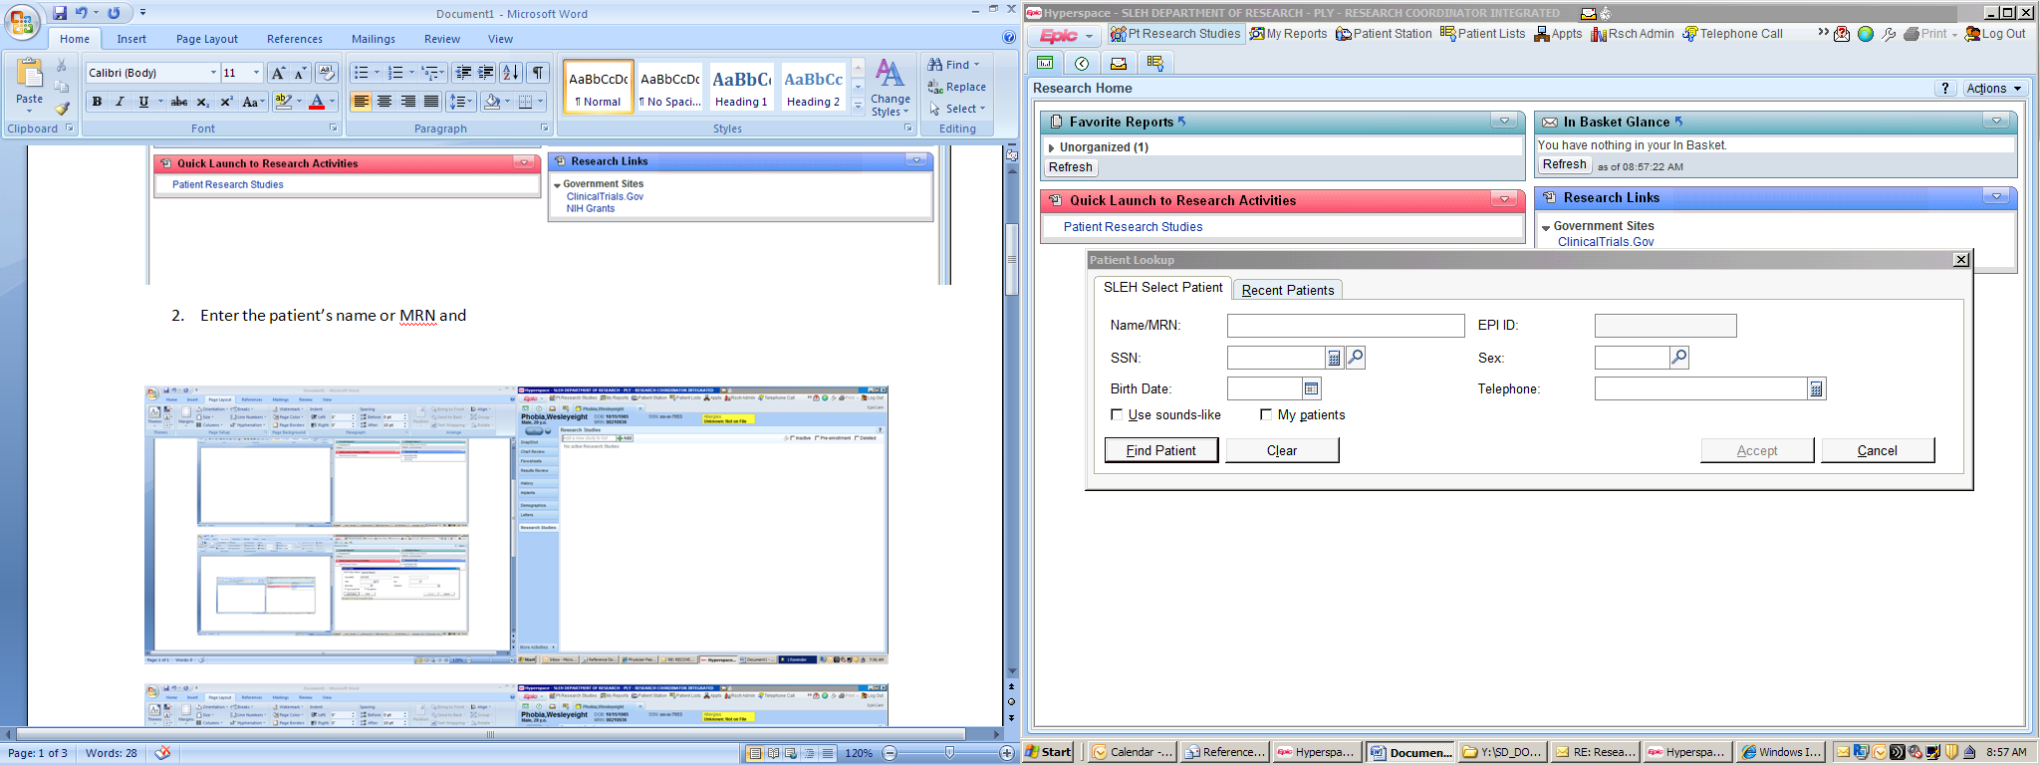

Step 3: Enter the IRB number for the study in the box provided and click “**Add**” OR click the “**Add**” button to search for the study:

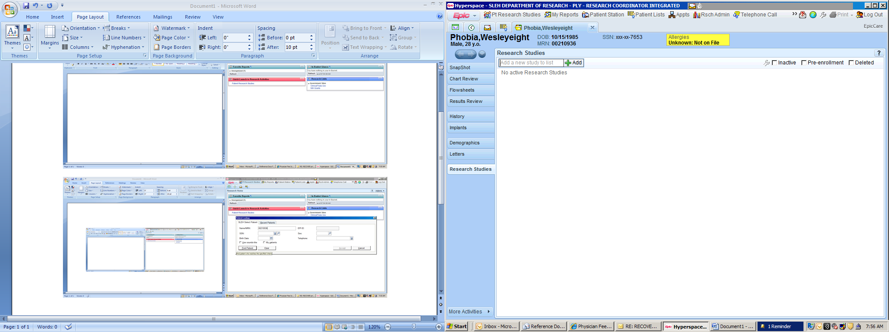

Step 4: Enter the following information and click “**Accept**”:

* 1. **Coordinators** (only EPIC users can be entered in these fields)
  2. **Status**: Several options available when the magnifying glass icon is clicked (Enrolled, Ineligible, Completed, etc.)
  3. **Active Start Date**: Date the Research Informed Consent Form (ICF) was signed
     1. **NOTE**: If a patient signs the ICF while admitted in the hospital and the ICF date is *after* the admission date, the admission date must be entered as the Active Start Date. For all other patients, the actual ICF date should be entered as the Active Start Date.
  4. **Comments**: Free text field can be utilized to add research notes or to document the informed consent process

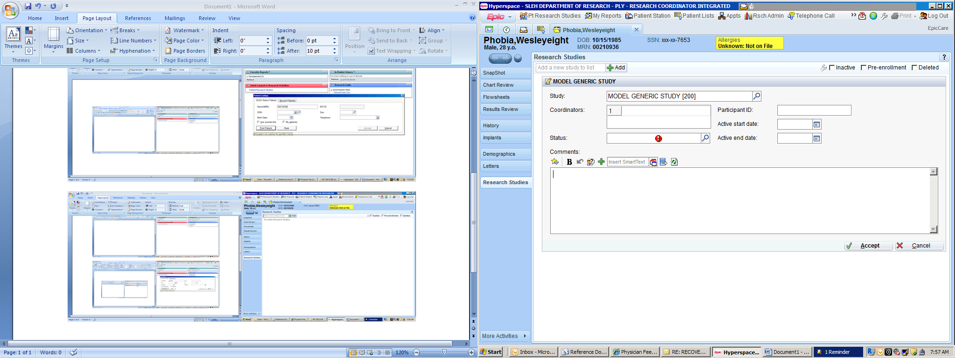

**d**a

**c**a

**b**a

**a**a

The patient’s record is now associated with the study.

## To link a specific encounter (visit) to the study in Epic

Step 1: Click on the “**Patient Station**” button. The “**Patient Lookup**” box will appear: Enter the patient’s name, MRN, or SSN and click on “**Find Patient**”:

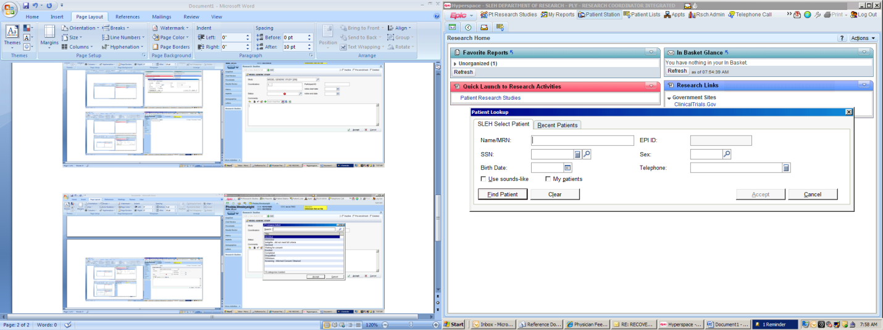

Step 2: Double click on the research related encounter (visit):

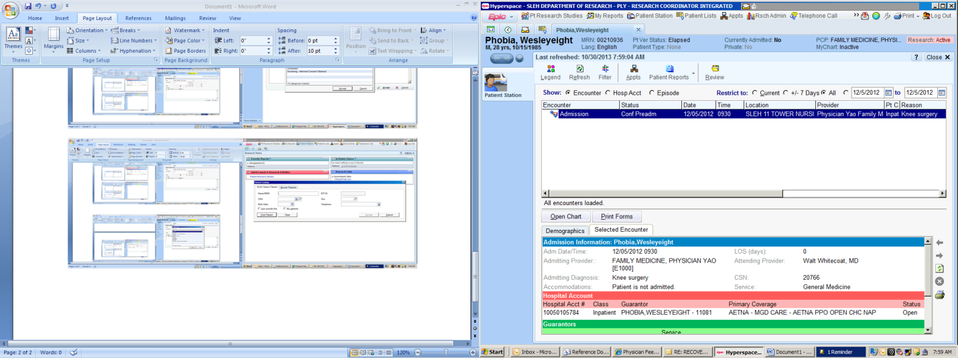

Step 3: Double click on “**Encounter Info**”:

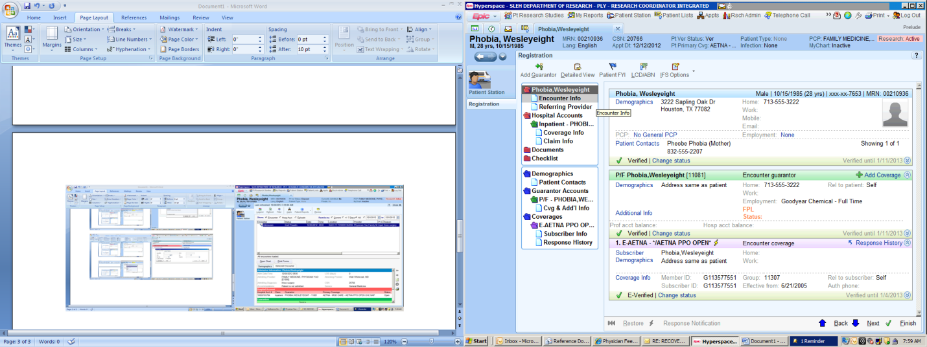

Step 4: Under “**Research Study**”, check the box by the study name and click on “**Finish**”:

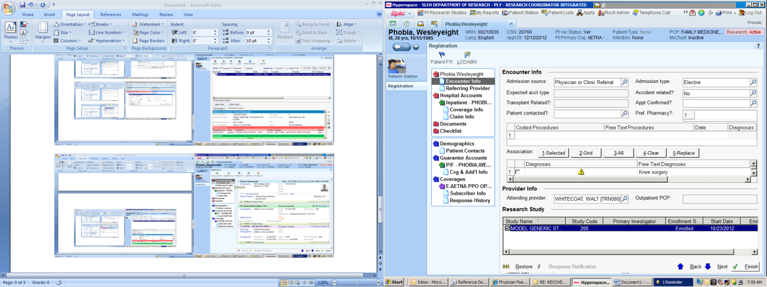

The encounter is now linked with the study.

### 

### Responsibility for maintaining current research patient status in Epic

Study teams are responsible for maintaining current research patient status in Epic. Statuses include identified; Interested; Ineligible – did not meet full criteria; Declined; Waiting for consent; Enrolled; Completed; Disqualified; and Withdrawn.

Study teams with Epic access may make this change directly in Epic. Study teams without Epic access must notify BSLMC Research Office when a patient goes off study by secure emailing [BSLMCPatientNotifications@bcm.edu](mailto:BSLMCPatientNotifications@bcm.edu) with the patient’s name, medical record number or date of birth, IRB# and off-study status (Completed, Disqualified, Withdrawn).

Reference: BSLMC Policy & Procedure, *Billing Compliance - Research*

## Associating Patient Records with Research Informed Consent Forms

Baylor St. Luke’s Medical Center requires that signed research informed consent forms are associated with research patients’ electronic medical records for all studies utilizing informed consent. The BSLMC Research Office conducts monthly reviews of all research encounters and will notify study teams of missing research informed consent forms.

If the patient is consented outside BSLMC, study teams should fax the signed research informed consent form along with the call center registration form when scheduling the patient’s BSLMC visit (see *Scheduling Research Visits at BSLMC**,* above). The Call Center will associate the research informed consent form with the patient’s medical record.

If the patient is consented at BSLMC, a copy of the signed research informed consent form should be sent to BSLMC Health Information as soon as feasibly possible. The signed research informed consent form can be placed on the patient chart by the study team, and it will be scanned into Epic for association with the patient’s medical record within 48 hours of discharge.

Alternately, study teams may hand-deliver informed research consent forms for association to:

BSLMC Health Information Management

6720 Bertner, room G-153

Attention: Health Information Management (HIM) Request Desk Supervisor/HIM Request Desk

The informed consent should list the patient name, date of birth, date of service, study short title, and patient MRN or CSN. Health Information Management will scan the informed consent into ChartMaxx, which makes the content available in the Epic media tab. Informed consents are typically scanned within 48 hours.

Reference: BSLMC Policy & Procedure, *Associating Patient Records with Informed Consents - Research*

# Research Charge Routing and Review

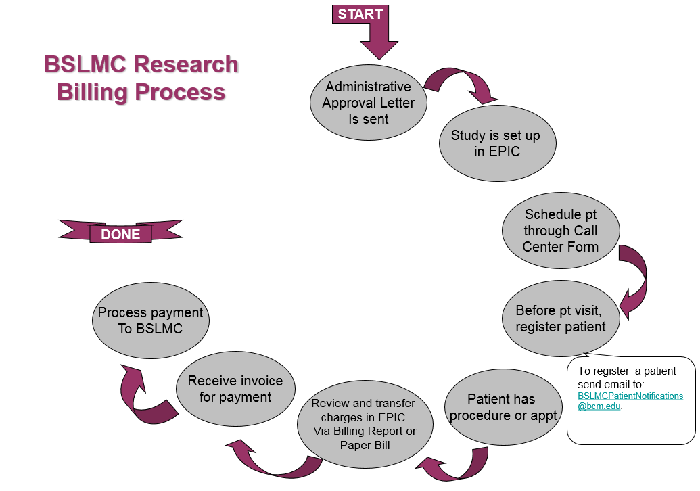

## Visit charge assignment

Following each study visit, the study team is required to assign visit charges as either standard of care and billable to the patient/insurance or as research and billable to the study account. Charge assignment must be completed within two business days of receipt of the billing report/paper bill. The process for this varies based on Epic access.

Research coordinators with Epic access can review charges for research patient visits on the Research Billing Review report, five days after closure of the encounter, transferring research items from the patient account to the study account, as shown below.

Coordinators without Epic access must review patient accounts on a clinical form and paper bill sent by Patient Financial Services, identifying which items on the bill are research and returning the itemized list to Patient Financial Services for transfer to the research study account, as shown below.

Any charges remaining on patient accounts after charge assignment will be billed routinely to the patient and/or patient’s insurance.

Reference: BSLMC Policy & Procedure, *Billing Compliance – Research*

### Charge assignment for coordinators with Epic access

To find the Research Billing Review report, go to My Reports->Library and search for “Research”. This will bring up all existing reports; see section *Patients Needing Research Billing Review – CHI*. You can find and “star” your report for easy identification.

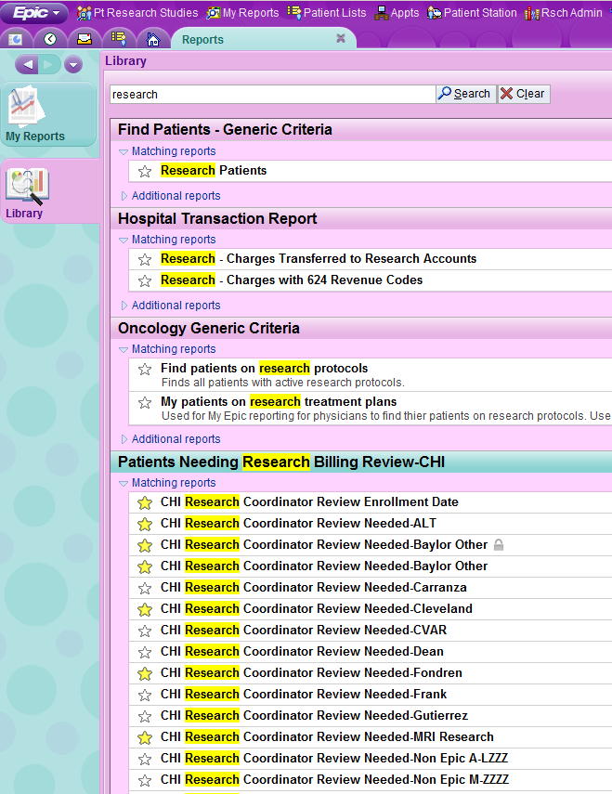

To view accounts ready for review, select your report and click *Run*. It may take a few minutes for the report to open.



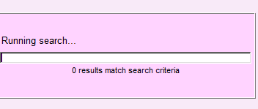

The report collates any patient records in the selected study billing review. Select the patient for review to open the account review screen.

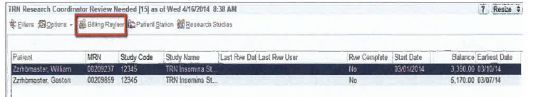

On this page, transfer charges considered research by clicking on the box next to the specific charge. When all research charges are selected, click on the *Research Correction* button, select *Research-related*, and select the correct study for charges. Uncheck *Patient/Insurance* if selected.

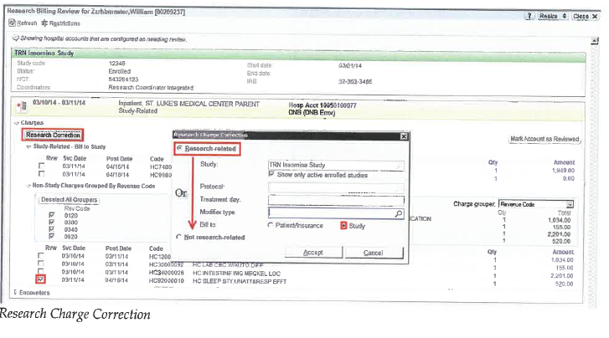

Click *Accept,* then *OK,* then *Refresh* button on the top left of your page and verify the correct charges transfer to the research study account. If correct, and there are no other charge transfers, click on *Mark Account as Reviewed* at middle right. Enter a note that the account was reviewed, then click *Accept.*



*Coordinator Reviewed* will appear on the Hospital Account Header.



Clicking on *Charges* shows reviewed charges with a green check mark.

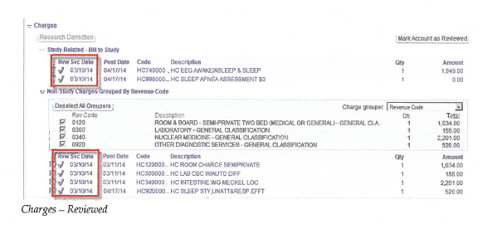

Transaction now shows charges moved to research accounts.

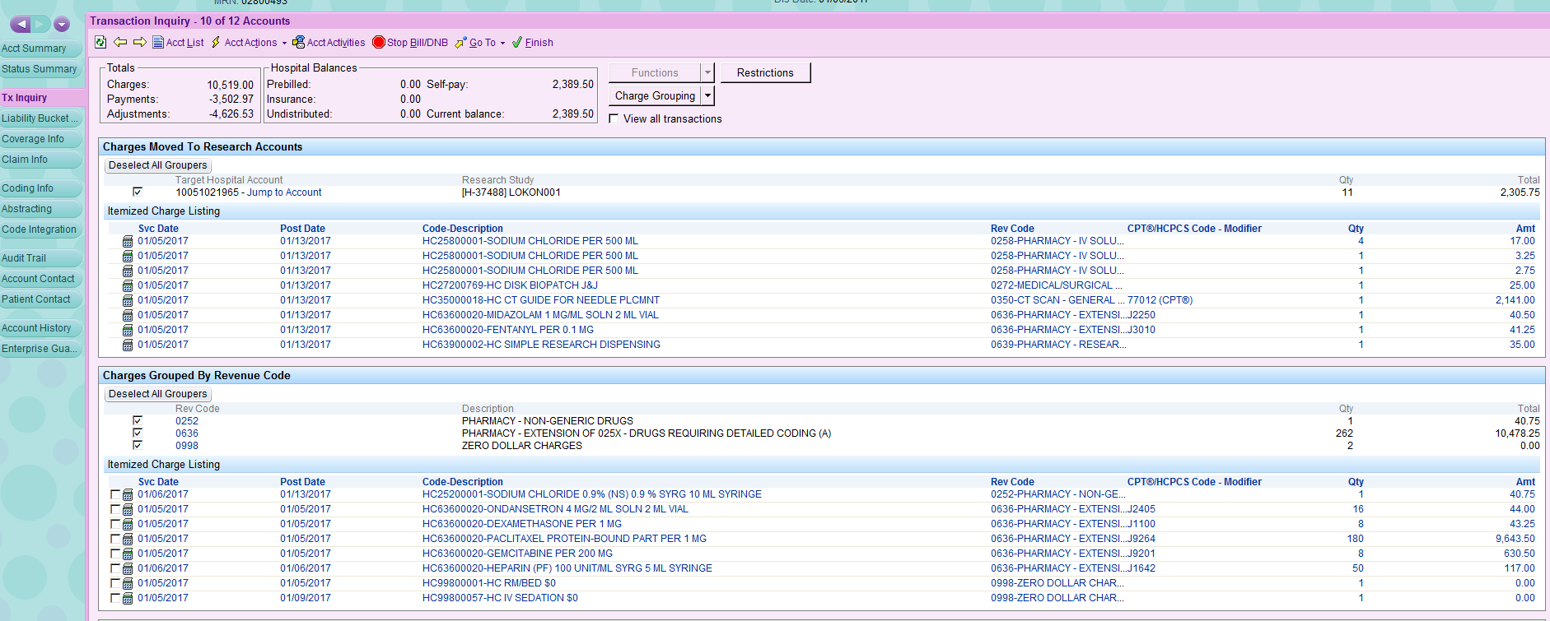

Transaction now shows charges moved to research accounts

### 

### Charge assignment for coordinators without Epic access

Coordinators must review the clinical form and patient bill to correctly assign charges, as shown below:

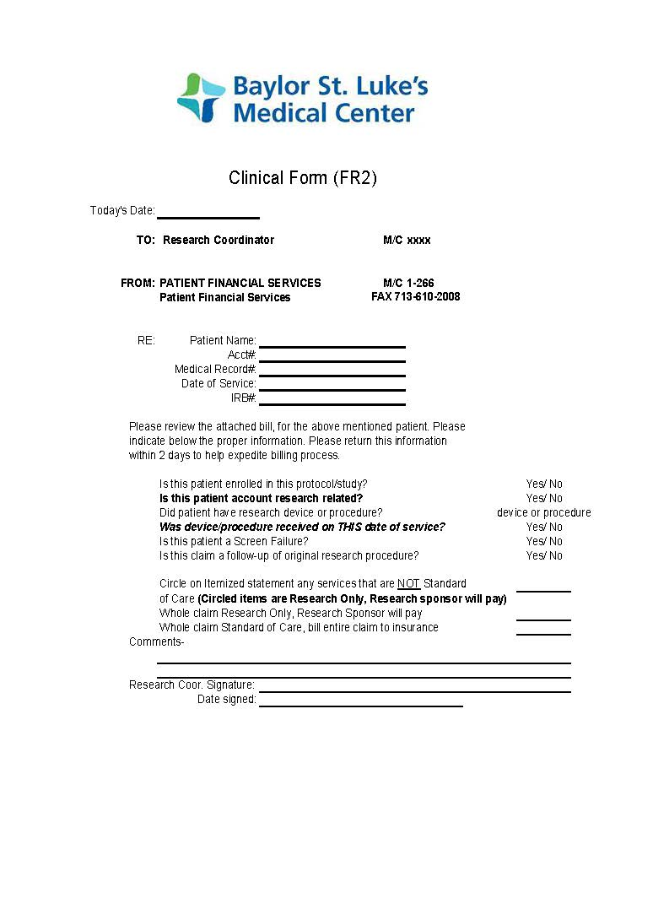

Sample Clinical Form for research visit, sent by Patient Financial Services to study team, along with patient bill. Coordinator should complete this form and indicate whether the associated bill is all research, all standard of care, or mixed. When only some items are research, these should be circled on the bill.

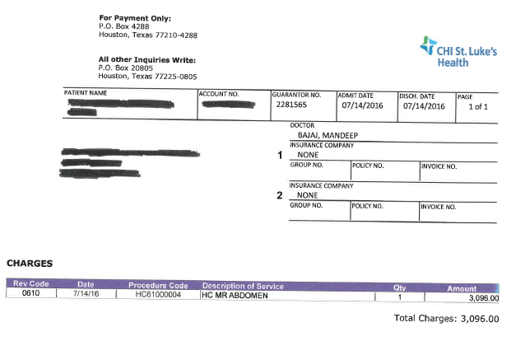

Sample patient bill, sent with the above clinical form. Study team should circle any items on the bill that should be charged to the study account and return the bill and clinical form to Patient Financial Services.

Patient Financial Services will move all research charges to the study account and mark the account as reviewed. Any charges not marked as research are sent for standard clinical billing. All remaining charges will be billed to patient/insurance.

### Monthly study account billing

On the fifth (5th) of each month, BSLMC Patient Financial Services will send the study team an invoice for all charges assigned to the study account for the previous month. The study team should review the charges and work with Patient Financial Services to make any needed adjustments. The invoice should be paid within three (3) months of receipt. If the study team expects a delay in payment, Patient Financial Services should be notified to avoid administrative hold on the study.

Reference: BSLMC Policy & Procedure *Billing Compliance – Research*

# BSLMC Clinical Research Center

The [Baylor St. Luke’s Medical Center Clinical Research Center](http://www.chistlukeshealth.org/clinical-research-center) (CRC) is a hospital-based unit providing comprehensive human studies infrastructure for clinical investigators. Launched in June 2016, the Center provides inpatient and outpatient research services and resources for clinical trials (Phase I-IV), metabolic studies, translational studies and pilot trials in all clinical areas.

The CRC is staffed by dedicated acute care nurses specially trained in the complex requirements of research studies. CRC staff work closely with study teams to ensure clinical study activities are conducted safely and appropriately, according to the workflow and sampling schedules of Institutional Review Board-approved protocols.

The BSLMC Clinical Research Center is located in the Texas Medical Center at Baylor St. Luke’s Medical Center (6720 Bertner Avenue), 20th floor inpatient unit. The Center provides the following resources and services for a flat hourly rate based on the study’s funding source. The rate is $90/hour for industry-sponsored studies and $50/hour for non-industry-sponsored studies. Study requirements not listed below will be billed separately.

**Resources and Services Included**

* Two dedicated inpatient rooms
* Basic medical supplies
* Vital signs, height and weight measurement
* Observation
* Assistance with physical examinations
* IV infusion
* Phlebotomy and blood sampling per protocol
* Central/peripheral line access and site care
* Medication administration
* Adverse event management
* Patient meal services
* Refrigerated centrifuge and -80oC freezer
* Access to BSLMC’s pathology lab
* Access to BSLMC’s dedicated research pharmacy

Study teams are encouraged to contact the CRC early in planning to discuss study needs. Please submit the *Request for Clinical Research Center Support*, available on the BSLMC Research website (sample attached, *Appendix V*) to initiate the CRC feasibility process. Also, see *Appendix V* for the CRC study initiation workflow. For more information about the CRC, please consult the Baylor St. Luke’s Medical Center Clinical Research Center Investigator Manual, or contact the CRC via phone or email:

Baylor St. Luke’s Medical Center Clinical Research Center

[BSLMC-CRC@bcm.edu](mailto:BSLMC-CRC@bcm.edu)

713-798-6024

# Device Study Impact Analysis

All device studies that require the hospital to purchase the device must undergo a financial impact analysis. This process provides for responsible allocation of hospital resources. For all investigational, humanitarian use, and post-market device studies to be conducted at the hospital, study teams must submit a request form to determine if their device study requires impact analysis. This process should be initiated as early in study startup as possible, as findings may impact study budgets.

If the device is provided free of charge by the sponsor, no analysis is required. If the hospital must purchase the device, impact analysis is required. The analysis is conducted by BSLMC Supply Chain and Finance, and is reviewed/approved by BSLMC executive leadership.

The impact analysis must be completed and approved by BSLMC leadership before administrative approval can be given and the hospital can purchase the device.

Please see the sample device assessment request form and impact assessment workflow in *Appendix VI*.

Reference: BSLMC Policy and Procedure, *Impact Assessment of Investigational/Humanitarian/Post-Market Devices - Research.*

# 

# Appendix I

## Instructions to provide view-only protocol access to BSLMC Research Office

You may follow the below procedures to provide view-only access to your protocol submission to the BSLMC Research Office. You may also instead elect to manually submit the protocol documents with your BSLMC Administrative Application.

**Baylor College of Medicine IRB**

Check the box for Baylor St. Luke’s Medical Center as a site on the BRAIN eSP1 protocol submission.

**CHI Institute for Research & Innovation IRB**

Enter your protocol in the [IRBNet system](http://www.chiresearch.org/CIRI/Human-Research-Protection-Program-IRB) and share the project with Angie Esquivel and Obi Ash of the BSLMC Research Office

**University of Texas IRB**

List Angie Esquivel as Administrative Assistant in the iRIS protocol application

**BRANY IRB**

Add BSLMC as a site where research will be performed and provide view-only access to Angie Esquivel ([aresquiv@bcm.edu](mailto:aresquiv@bcm.edu)) and Obi Ash ([Obiajulum.Ashibuogwu@bcm.edu](mailto:Obiajulum.Ashibuogwu@bcm.edu))

**Western IRB**

Add BSLMC as a site where research will be performed and provide view-only access to Angie Esquivel ([aresquiv@bcm.edu](mailto:aresquiv@bcm.edu)) and Obi Ash ([Obiajulum.Ashibuogwu@bcm.edu](mailto:Obiajulum.Ashibuogwu@bcm.edu))

# Appendix II

## Sample BSLMC Application for Administrative Review

* Please visit [http://www.chistlukeshealth.org/research](http://www.chistlukeshealth.org/research-coordinator-tools) for the most current version



## 

***Application for Administrative Review of Research***

**Instructions:**

Before conducting any study activities at Baylor St. Luke’s Medical Center (BSLMC), please complete this form and submit to [BSLMC_Research@bcm.edu](mailto:BSLMC_Research@bcm.edu) for BSLMC review and approval. You are encouraged to submit this form early in study start-up in order to initiate the review process. You may not conduct any study activities at BSLMC prior to receiving confirmation that you have BSLMC administrative approval. For questions, please contact the BSLMC Research Office at 713-798-6024

|  |  |  |  |  |  |  |  |  |  |  |  |  |  |  |  |  |  |  |  |  |  |  |  |  |
| --- | --- | --- | --- | --- | --- | --- | --- | --- | --- | --- | --- | --- | --- | --- | --- | --- | --- | --- | --- | --- | --- | --- | --- | --- |
| IRB of Record: ☐ BCM ☐ BRANY ☐ CHIRB ☐ WIRB ☐ NCI IRB ☐ UT IRB | | | | | | | | | | | | | | | | | | | | | | | | |
| *If this project will be managed by Catholic Health Initiatives Institute for Research and Innovation, please complete the supplement found* [***here***](http://www.chistlukeshealth.org/research-coordinator-tools) *and upload to this application in the study documentation section. For CHIRB studies, the supplement and this administrative application form must be attached to the CHIRB submission.* | | | | | | | | | | | | | | | | | | | | | | | | |
| IRB of record #: | | | |  | | | | | | BCM H# (if applicable): | | | | | | | | |  | | | | | |
| Proposed Project Period: | | | |  | | | | | | Short Title (for Epic account): | | | | | | | | | |  | | | | |
| Study Title: | | | |  | | | | | | | | | | | | | | | | | | | | |
| Physical study address for BSLMC hospital invoices: | | | |  | | | | | | | | | | | | | | | | | | | | |
| Brief description of study and purpose–this will be provided to BSLMC areas utilized by study. Do not exceed 150 words. | | | | | | | | | | | | | | | | | | | | | | | | |
|  | | | | | | | | | | | | | | | | | | | | | | | | |
|  | | | | | | | | | | | | | | | | | | | | | | | | |
| Principal Investigator (PI) last/first name: | | | | | | | | | | | | | | | | | | | | | | | | |
| PI’s primary institution/employer: | | | | | | | | | | | | | | | | | | | | | | | | |
| PI’s department/section or medical specialty: | | | | | | | | | | | | | | | | | | | | | | | | |
| PI’s email: | | |  | | | | | | | | | | PI’s phone: | | | | | | | | | | | |
|  | | | | | | | | | | | | | | | | | | | | | | | | |
| Study Administrative Contact last/first name: | | | | | | | | | | | | | | | | | | | | | | | | |
| Study Admin email: | | |  | | | | | | | | | | Study Admin phone: | | | | | | | | | | | |
|  | | | | | | | | | | | | | | | | | | | | | | | | |
| Check if financial contact same as administrative contact | | | | | | | | | | | | | | | | | | | | | | | | |
| Financial Contact Last/first name: | | | | | | | | | | | | | | | | | | | | | | | | |
| Financial email: | | | | | | | | | | | | | Financial phone: | | | | | | | | | | | |
|  | | | | | | | | | | | | | | | | | | | | | | | | |
| Study sponsor: | | |  | | | | | | Funding source (if other than sponsor): | | | | | | | | | | | |  | | | |
| Study Type/Phase: | | | **Select Type** | | | | **Select Phase** | | Does this study require collection of tissue at BSLMC for research purposes? | | | | | | | | | | | | **Select** | | | |
| *If this is a device study, please complete the IDE/HDE request form, available on the BSLMC research website, and submit as soon as possible. All device studies conducted at BSLMC must have an approved device impact analysis before administrative approval can be provided. This process should be completed prior to conducting budget negotiations with the sponsor.* | | | | | | | | | | | | | | | | | | | | | | | | |
| *If this is a drug study, please contact the BSLMC Research Pharmacy as early as possible in the study preparation stage to initiate pharmacy pricing for incorporation to your study budget: 832-355-6892; 832-355-4893;* [*phinsu@stlukeshealth.org*](mailto:phinsu@stlukeshealth.org) | | | | | | | | | | | | | | | | | | | | | | | | |
| If questionnaire, will BSLMC employees be included? | | | | | | | | | | | | | | | **Select** | | | | | | | | | |
| Will subjects be consented in BSLMC facilities? | | | | | **Select** | | | If yes, who will be responsible for conducting the consent process? | | | | | | | | | | **Select** | | | | | | |
| If yes, are there potential risks to the fetus if a female subject should become pregnant? | | | | | | | | | | **Select** | | | | | | |
| IND/IDE number, if drug or device study | | | | |  | | | Clinicaltrials.gov NCT # | | | | | | | | | |  | | | | | | |
| Is this a multi-site study for which Baylor St. Luke’s Medical Center is the coordinating site? | | | | | | | | | | | | | | | | | | **Select** | | | | | | |
| *If yes, please name sites on separate sheet and indicate if the sites are Catholic Health Initiative facilities – for example, CHI St. Luke’s Health Sugar Land Hospital, CHI St. Luke’s Health The Woodlands Hospital. Visit* [*http://www.catholichealthinitiatives.org/*](http://www.catholichealthinitiatives.org/) *to view a list of locations. Attach sheet to this application* | | | | | | | | | | | | | | | | | | | | | | | | |
| ***STUDY PERSONNEL*** | | | | | | | | | | | | | | | | | | | | | | | | |
| List name, role and email for all study personnel who will conduct study activities at BSLMC or access BSLMC protected health information (PHI). Add rows as needed.  BSLMC Research Office will verify Principal Investigator is currently credentialed at BSLMC. All study personnel who will conduct study activities at BSLMC are responsible for obtaining appropriate badging or credentialing from BSLMC Medical Staff Services, based on their study role. Please contact BSLMC Research Office to be put in contact with Medical Staff Services.  CITI Training is required prior to administrative approval. All Non-BCM/BSLMC study personnel must attach proof of completion:   * Human Subjects Research (Biomedical Research Basic/Refresher) * Researcher COI * Information Privacy and Security (any HIPAA course acceptable; does not have to be CITI) * Good Clinical Practice (required for IND/IDE studies – any GCP course acceptable; does not have to be CITI) | | | | | | | | | | | | | | | | | | | | | | | | |
| **Name, Institution & Study Role** | | | | | | | | | | | | | | | | | | | | | | **Email** | | |
|  | | | | | | | | | | | | | | | | | | | | | |  | | |
|  | | | | | | | | | | | | | | | | | | | | | |  | | |
|  | | | | | | | | | | | | | | | | | | | | | |  | | |
|  | | | | | | | | | | | | | | | | | | | | | |  | | |
|  | | | | | | | | | | | | | | | | | | | | | |  | | |
|  | | | | | | | | | | | | | | | | | | | | | |  | | |
|  | | | | | | | | | | | | | | | | | | | | | |  | | |
|  | | | | | | | | | | | | | | | | | | | | | |  | | |
|  | | | | | | | | | | | | | | | | | | | | | |  | | |
|  | | | | | | | | | | | | | | | | | | | | | |  | | |
|  | | | | | | | | | | | | | | | | | | | | | |  | | |
| ***STUDY DOCUMENTATION*** | | | | | | | | | | | | | | | | | | | | | | | | |
| **REQUIRED WITH APPLICATION SUBMISSION** | | | | | | | | | | | | | | | | | | | | | | | | |
| Attached  N/A | | | | | Protocol | | | | | | | | | | | | | | | | | | | |
| Attached  N/A | | | | | Informed Consent (draft or approved), if applicable | | | | | | | | | | | | | | | | | | | |
| Attached  N/A | | | | | Schedule of Events for all procedures. Must indicate which procedures take place at BSLMC and include CPT codes for outpatient procedures and ICD-10 for inpatient procedures. Must indicate which procedures are paid by research and which are standard of care, and be signed by principal investigator. | | | | | | | | | | | | | | | | | | | |
| Attached  N/A | | | | | CITI training certificates for all non-BCM/BSLMC listed personnel | | | | | | | | | | | | | | | | | | | |
| **ADDITIONAL DOCUMENTS** | | | | | | | | | | | | | | | | | | | | | | | | |
| Attached  Pending | | | | | Copy of IRB approval letter. Not required at time of administrative application submission but must be submitted before administrative approval is issued. | | | | | | | | | | | | | | | | | | | |
| Attached  N/A | | | | | Drug studies must attach the investigator’s brochure, if available. | | | | | | | | | | | | | | | | | | | |
| Attached  N/A | | | | | Imaging protocol and/or pharmacy dispensing protocol (if applicable) | | | | | | | | | | | | | | | | | | | |
| Attached  N/A | | | | | Request for Clinical Research Center Support | | | | | | | | | | | | | | | | | | | |
| Attached  N/A | | | | | Supplement for Studies Managed by Catholic Health Initiatives Institute for Research and Innovation (CIRI) | | | | | | | | | | | | | | | | | | | |
| Attached  N/A | | | | | List of CHI study sites, not including BSLMC | | | | | | | | | | | | | | | | | | | |
|  | | | | |  | | | | | | | | | | | | | | | | | | | |
| ***DEPARTMENTS/AREAS & REGULATORY COMMITTEES*** | | | | | | | | | | | | | | | | | | | | | | | | |
| * Check all that will be utilized for this study. * Note: each utilized area must administratively approve before BSLMC administrative approval can be given. * Include a brief (1-3 sentences) description of activities that will be conducted, anticipated number of patients to be seen in the area and how area staff will be impacted. For clinical areas, indicate if research visits will be part of the normal clinical workflow. | | | | | | | | | | | | | | | | | | | | | | | | |
| **Special Regulatory Committees -** | | | | | | | | | | | | | | | | | | | | | | | | |
| Lasers: | | | | | | *Describe work to be performed* | | | | | | | | | | | | | | | | | | |
| Radiation/Radioisotopes/Nuclear Medicine: | | | | | | *Describe work to be performed* | | | | | | | | | | | | | | | | | | |
| Recombinant DNA – Institutional Biosafety Committee | | | | | | Attach a copy of approval letter from PI’s institutional IBC | | | | | | | | | | | | | | | | | | |
| **Hospital Services-** | | | | | | | | | | | | | | | | | | | | | | | | |
| Clinical Research Center | | | | | | *Complete Request for Clinical Research Center Support and submit along with this application* | | | | | | | | | | | | | | | | | | |
| Research Pharmacy | | | | | | *Describe work to be performed. Contact the research pharmacy as soon as possible to initiate pharmacy pricing (832-355-892; 832-355-4893;* [*phinsu@stlukeshealth.org*](mailto:phinsu@stlukeshealth.org)*)*  *Note that research drug should not be sent to the pharmacy until administrative approval is received.* | | | | | | | | | | | | | | | | | | |
| BSLMC pathology-lab tests | | | | | | *Describe work to be performed* | | | | | | | | | | | | | | | | | | |
| BSLMC pathology-tissue collection | | | | | | Expected number of samples: | | | | | | | |  | | | | | | | | | | |
| Site/Organ: | | | | | |  | | | | | | | | | | | | | | | | | | |
| Specific tissue or cell type needed: | | | | | |  | | | | | | | | | | | | | | | | | | |
| Slides: | | | | | | Type of stain required: | | | | |  | | | | | | Number of slides per specimen: | | | | | | |  |
| Tissue: | | | | | | Fresh  Frozen/Snap Freeze  Paraffin Block (Slices)  Fixed | | | | | | | | | | | | | | | | | | |
| Custom slides to be  prepared from tissue: | | | | | | Type of stain required: | | | |  | | | | | | Number of slides per specimen: | | | | | | |  | |
| Radiology & Interventional Radiology for Research | | | | | | Imaging Modality:  MRI  CT  US DXA  Other: _______________ | | | | | | | | | | | | | | | | | | |
| Expected number of imaging sessions needed per subject out of N total subjects: | | | | | | | | | | | | | | | | | | |
| Anonymized Images Requested?  CD  FTP  Web-based transfer | | | | | | | | | | | | | | | | | | |
| Does study require contrast or imaging related intervention?  Yes  No | | | | | | | | | | | | | | | | | | |
| *Note radiology research invoices separately from the hospital for non-standard imaging. For radiology-related questions, contact Debra Dees (*[*ddees@stlukeshealth.com*](mailto:ddees@stlukeshealth.com)*; 832-355-7501 or Melissa Andrews (*[*mandrews@stlukeshealth.com*](mailto:mandrews@stlukeshealth.com)*; 832-355-2797).* | | | | | | | | | | | | | | | | | | | | | | | | |
| **Clinical Departments and Areas-** | | | | | | | | | | | | | | | | | | | | | | | | |
| Inpatient | | | | | Outpatient | | | | | | | Length of Visits (Hrs:Min): | | | | | | | | |  | | | |
| Circulatory Support– orders & stores non-catheter investigational devices | | | | | *Provide number of devices and space requirements for storage and/or describe work* | | | | | | | | | | | | | | | | | | | |
| Catheterization Lab- orders & stores catheterization investigational devices | | | | | *Provide number of devices and space requirements for storage and/or describe work* | | | | | | | | | | | | | | | | | | | |
| Nursing Service- for notifying nurse management of study activities | | | | | *Describe work and service areas where visits will occur* | | | | | | | | | | | | | | | | | | | |
| Operating Room | | | | | *Describe work and service areas where visits will occur* | | | | | | | | | | | | | | | | | | | |
| Endoscopy | | | | | *Describe work and service areas where visits will occur* | | | | | | | | | | | | | | | | | | | |
| Texas Heart Institute Clinic | | | | | *Describe work and service areas where visits will occur* | | | | | | | | | | | | | | | | | | | |
| Other: *Insert designation* | | | | | *Describe work and service areas where visits will occur* | | | | | | | | | | | | | | | | | | | |
|  | | | | | | | | | | | | | | | | | | | | | | | | |
| ***Attestations: Please check to acknowledge compliance*** | | | | | | | | | | | | | | | | | | | | | | | | |
| ☐ | All personnel conducting research at BSLMC must be appropriately credentialed and/or badged. | | | | | | | | | | | | | | | | | | | | | | | |
| ☐ | Any study equipment that will come into contact with patients and requires electrical outlet access must be signed off by BSLMC Clinical Engineering (832-355-8585). The study team is responsible for contacting Clinical Engineering. | | | | | | | | | | | | | | | | | | | | | | | |
| ☐ | The study team is responsible for completing in-service training for staff in all patient care areas where the study will be conducted, **prior** to beginning the study. | | | | | | | | | | | | | | | | | | | | | | | |
| ☐ Submitted to IRB of record | | | | | Current Investigator Financial Disclosure and Declaration Forms must be submitted to the IRB of record for all individuals performing work that directly impacts the proposed project. | | | | | | | | | | | | | | | | | | | |
| **COMPLETED BY*:** | | | | | ***Required*** | | | | | | | | | | | | | | | | | | | |
| ***Principal Investigator: ACKNOWLEDGEMENT OF REQUIREMENTS*** | | | | | | | | | | | | | | | | | | | | | | | | |
| **Principal Investigator** – Review and initial each statement (typed initials acceptable) below to indicate your agreement to fulfill these requirements for protected health information (PHI) and human subjects research. | | | | | | | | | | | | | | | | | | | | | | | | |
|  | | To comply with HIPAA and HITECH laws and regulations regarding Uses and Disclosures of Protected Health Information (PHI), Investigators are responsible for maintaining records of all PHI access requests disclosed without Subjects’ authorization. The *Request for Access to PHI for Research Purposes form* should be completed and kept with study records for all such PHI access requests. | | | | | | | | | | | | | | | | | | | | | | |
|  | | I will adequately destroy all PHI data per federal/state regulations and BSLMC policies. | | | | | | | | | | | | | | | | | | | | | | |
|  | | I have been trained on the use of PHI with respect to its use and disclosure in research activities and protocols. | | | | | | | | | | | | | | | | | | | | | | |
|  | | No PHI will be stored on a device that has not been encrypted by BSLMC IT (examples: laptops, CDs, non-BSLMC computers, and zip drives). (Contact BSLMC IT for encryption: 832-355-8000). | | | | | | | | | | | | | | | | | | | | | | |
|  | | I agree to fully abide by all St. Luke’s policies and procedures formulated to ensure compliance with Human Subject Research and HIPAA Privacy and Security. | | | | | | | | | | | | | | | | | | | | | | |
|  | | As Principal Investigator, I approve this application for submission to BSLMC. | | | | | | | | | | | | | | | | | | | | | | |

|  |  |
| --- | --- |
| **COMPLETED BY*:** | ***Required*** |
|  | Name/Date |
| **REVIEWED/APPROVED BY PRINCIPAL INVESTIGATOR*:** | ***Required*** |
|  | Signature/Date |

* Typed signatures acceptable

## Sample Research Financial Agreement

* Information will vary based on your study 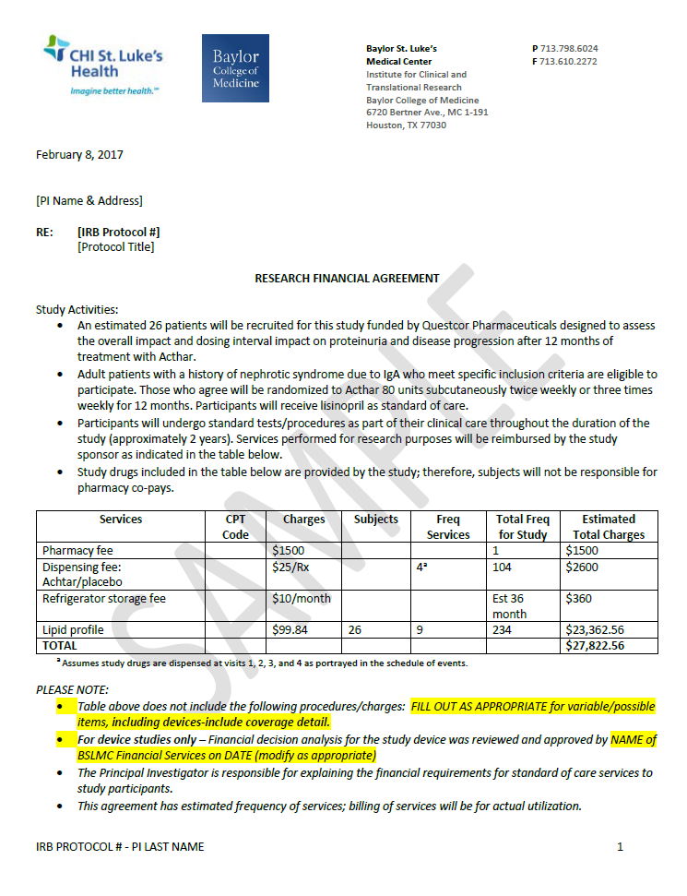

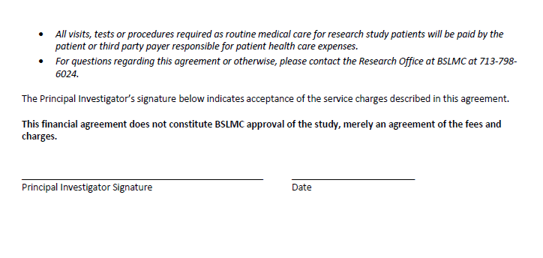

## Sample Request for Access to PHI for Research Purposes Form

[](http://www.chistlukeshealth.org/baylorstlukes)

**Request for Access to Protected Health Information for a Research Purpose without Subject’s Authorization**

**Instructions:** Research is defined in the HIPAA Privacy Rule as “a systematic investigation, including research development, testing, and evaluation, designed to develop or contribute to generalizable knowledge.” In order to comply with HIPAA and HITECH laws and regulations governing covered entities, individuals engaged in Research at Baylor St. Luke’s Medical Center (BSLMC) must document their requests to use Protected Health Information (PHI) for research purposes without a patient’s authorization. Researchers must complete and maintain a copy of this form for all such requests. A copy of the form must also be provided to the office providing access (such as Health Information Management), as applicable. Questions regarding this form or related regulations you should contact [BSLMC_Research@bcm.edu](mailto:BSLMC_Research@bcm.edu)

**Principal Investigator (PI) Name:** ___________________________________________________________________

**PI Primary Institution/Employer:** ___________________________________________________________________

**PI email/phone:** _________________________________________________________________________________

**Administrative contact name/email/phone:** __________________________________________________________

**Research Project Title:** _____________________________________________________________________________

1. I hereby request to review individually identifiable health records for the named research project for which the Individual’s authorization is not available. I represent that the PHI to which access is sought is necessary to the research and will be used solely for the named research project. My request is based upon the following authorization/justification. I have attached the required documents as indicated.

Subject’s written authorization WAIVED by IRB (full or partial waiver)

1. Copy of IRB-approved waiver of consent
2. Copy of IRB approval letter

Decedents’ health Information only.

1. I agree that, upon request, I will provide documentation of the death of the individuals whose health information I will review.
2. Brief description of research purpose and health information requested
3. Copy of IRB approval letter

Information is preparatory to research only. No PHI will be recorded or removed from the area of review.

1. I agree that no PHI will be emailed or stored on a flash drive, laptop, or otherwise recorded or removed from BSLMC (the “covered entity”. I agree that health information will only be recorded in a manner such that the subject cannot be identified (identifiers include name, MRN, dates, etc.) I agree that if I want to record any identifiers including dates (of birth, service, etc.), then either a HIPAA waiver or subject authorization must be obtained. I understand that failure to abide by these conditions will result in automatic termination of access to PHI for research purposes.
2. Brief description of research purpose and health information requested
3. Type of health information to which access is requested

Electronic records. Database to be queried: ____________________________

Paper records: Describe source/location

Imaging

Other: Describe

1. List all individuals who will have access to the requested PHI and their roles (i.e., co-investigator, study coordinator): _________________________________________________________________________________________________________________________________________________________________________________________________________________________________________________________________________________
2. Please check one of the following:

I have attached a list of records that I am requesting from Health Information Management. (The list must include the project title and PI name, full legal name of patient, patient’s date of birth or SSN and medical record number when available).

I am requesting that a list of records be generated for me by Health Information Management. I have attached a description of records I am looking for (include project title and PI name)

I and/or the individuals listed above will directly access PHI under preexisting EPIC authorization and do not require assistance by Health Information Management.

***I agree that the information I have requested will only be used for the research purpose as stated in this form and its accompanying documentation. I will protect the confidentiality and security of this information while it is in my possession and will destroy identifiers if required by accompanying documentation.***

___________________________________________________________________________________

Signature of Principal Investigator*

________________________________________________

Date

For HIM support, the completed form should be sent to Nanette Moreno, Systems Administrator, Health Information Management ([nmoreno@stlukeshealth.org](mailto:nmoreno@stlukeshealth.org)). No information can be released without IRB approval.

*\* Electronic or typed signatures are acceptable if form is sent from Principal Investigator’s email address.*

# 

# Appendix III

## BSLMC Research Compliance Review – HIPAA Authorization Language

## List of Required Elements

All studies submitted for BSLMC Administrative Approval will receive a compliance review from the BSLMC Research Office, prior to approval. The following items will be checked for each study.

* **Is the Research Informed Consent Form compliant with HIPAA Authorization Requirements (see next section)?** Please note, the Research Informed Consent Form should list BSLMC as an institute which may disclose **and** receive PHI related to the study.
* **Is a waiver of consent needed? If so, has it been received?**
* **Is the study team compliant with Conflict of Interest Requirements?**  Study personnel listed in the administrative application will be checked for compliance with their institution’s COI disclosure requirements.
* **Will other CHI Facilities be utilized?** This applies to studies utilizing, for example, the Woodlands Hospital or the Sugar Land Hospital.If yes, the BSLMC Research Office will confirm the study team has contacted the site to ensure site research requirements are met.
* **Is Further Regulatory Review Needed? If so, has it been received?** (i.e., Laser Committee Review, Radiation Safety Committee Review, Institutional Biosafety Committee (IBC) review, Medicare Administrative Coordinator (MAC) Authorization for Investigational Device Exemption (IDE))

**HIPAA Authorization Language – List of Required Elements**

* + Description of PHI to be used or disclosed (identifying the information in a specific and meaningful manner).
  + The name(s) or other specific identification of person(s) or class of persons authorized **to make the requested use or disclosure.**
  + The name(s) or other specific identification of the person(s) or class of persons **who may use the PHI or to whom the covered entity may make the requested disclosure.**
  + Description of each purpose of the requested use or disclosure. Researchers should note that this element must be research study specific, not for future unspecified research.
  + Authorization expiration date or event that relates to the individual or to the purpose of the use or disclosure (the terms "end of the research study" or "none" may be used for research, including for the creation and maintenance of a research database or repository).
  + Signature of the individual and date. If the Authorization is signed by an individual's personal representative, a description of the representative's authority to act for the individual.

**Authorization Required Statements** (see Privacy Rule, *45 C.F.R.* § 164.508(c)(2))

* The individual's right to revoke his/her Authorization in writing and either (1) the exceptions to the right to revoke and a description of how the individual may revoke Authorization or (2) reference to the corresponding section(s) of the covered entity's Notice of Privacy Practices.
* Notice of the covered entity's ability or inability to condition treatment, payment, enrollment, or eligibility for benefits on the Authorization, including research-related treatment, and, if applicable, consequences of refusing to sign the Authorization.
* The potential for the PHI to be re-disclosed by the recipient and no longer protected by the Privacy Rule. This statement does not require an analysis of risk for re-disclosure but may be a general statement that the Privacy Rule may no longer protect health information.[*](https://privacyruleandresearch.nih.gov/authorization.asp#FOOTNOTE1)

# Appendix IV

## Sample Call Center/Registration Form

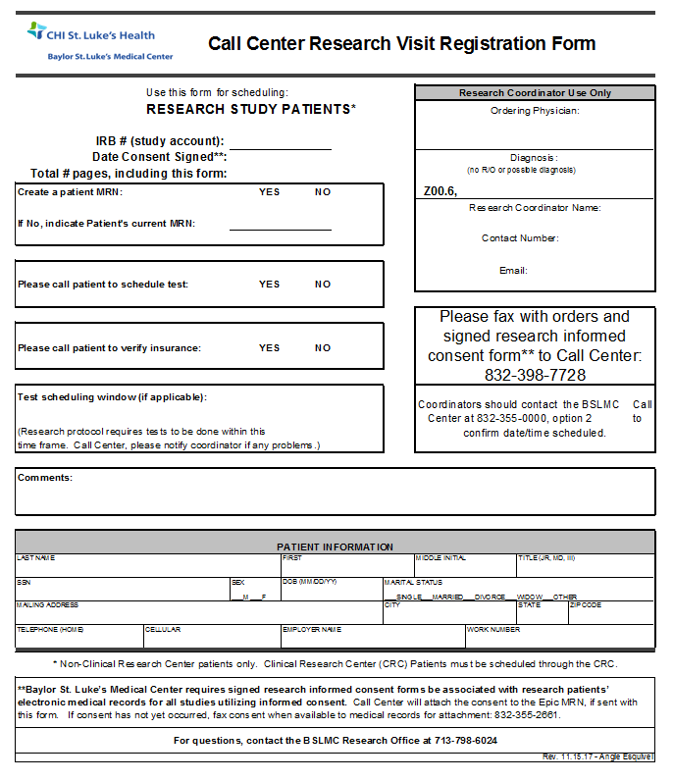

# Appendix V

## [http://www.chistlukeshealth.org/images/logo_baylor.png](http://www.chistlukeshealth.org/baylorstlukes)Sample of Request for Clinical Research Center Support

**Request for Clinical Research Center Support**

**Instructions:** To inquire regarding support of the Baylor St. Luke’s Medical Center (BSLMC) Clinical Research Center (CRC), please complete this form and email to [BSLMC-CRC@bcm.edu](mailto:BSLMC-CRC@bcm.edu). A member of the CRC team will contact you to schedule a feasibility meeting.

|  |  |  |  |  |
| --- | --- | --- | --- | --- |
|  | | | | |
| IRB of record #: |  | Principal Investigator: |  | |
| Study funding source: | Industry  Non-industry | | | |
|  | | | | |
| Expected/requested CRC start date: |  | Estimated study duration (years/months/days): | |  |
| Anticipated total number of subjects to be seen at CRC: |  | Anticipated total # of CRC visits per subject: | |  |
| List each visit you wish to have conducted at the CRC, including the anticipated day of the week, start time, and number of hours/visit. | |  | | |
|  | | | | |
| Completed | Attach the study schedule of events and clearly indicate which procedures will be performed by CRC nurses and which by study staff. | | | |
| **Study supplies and equipment** | | | | |

|  |  |  |
| --- | --- | --- |
| Please list **all** supplies and equipment needed by the study during CRC visits. Add rows as needed. When relevant, provide detailed information, such as manufacturer and model number or tube color and volume.  Certain supplies and equipment are available from BSLMC, including: access to ice, a 4°C refrigerator, vital sign machine, weighing scale, refrigerated centrifuge, ultra-low freezer and basic medical supplies. The BSLMC Research Office will work with you to determine which items will be provided by the CRC and by the study team. | | |
|  | |  |
|  | | |
| **REVIEWED/APPROVED BY PRINCIPAL INVESTIGATOR:** |  | |
|  | Signature/Date | |

Clinical Research Center Study Initiation Workflow

# Appendix VI

## Sample Device Impact Assessment Request Form

**Investigational/Humanitarian Device/Post- Market Device Impact Assessment Request Form**

Baylor St. Luke’s Medical Center (BSLMC) requires hospital approval of investigational/humanitarian device purchase and purchase of approved devices not currently stocked by the hospital. Approval is based on an assessment of the financial and clinical impact to the hospital. The assessment should be completed prior to conducting budget negotiations with the sponsor.

All device studies conducted at BSLMC must have an approved device impact form before administrative approval can be provided. **Please submit this completed form with all required documentation as early in the study process as possible to** [BSLMC_Research@bcm.edu](mailto:BSLMC_Research@bcm.edu)**.**

|  |  |  |  |  |
| --- | --- | --- | --- | --- |
| Principal Investigator: |  | | | |
| Protocol title: |  | | | |
| IDE/HDE number: |  | Study device  CMS category: | | Category A  Category B  N/A – HDE  N/A – Post-Market |
| Study device trade name: |  | Study device  common name: | |  |
| Study device manufacturer: |  | Manufacturer Catalog identifying number, if available: | |  |
| Sponsor/company contact: |  | Email & Phone number: | |  |
| **Are the device and all required components and accessories provided free of charge by the sponsor?** | | **Yes*  No **  N/A – Post-Market** | | |
| * If **Yes**, do not complete the rest of this form. Submit this form to the BSLMC Research Office ([BSLMC_Research@bcm.edu](mailto:BSLMC_Research@bcm.edu)) for approval to proceed with BSLMC administrative review. | | | | |
| ** If **No or N/A**, please complete the remainder of this form and submit the entire form with required documentation to [BSLMC_Research@bcm.edu](mailto:BSLMC_Research@bcm.edu) The hospital will conduct an impact analysis to determine if the hospital may approve the purchase. **It is essential that all sections are completed accurately.** Please contact [BSLMC_Research@bcm.edu](mailto:BSLMC_Research@bcm.edu) with questions.  Please await device purchase approval before proceeding with budget negotiations. You may proceed with submission of your BSLMC administrative application; however, submission of this device form does not guarantee hospital approval of device purchase. | | | | |
| What is the proposed device purchase amount **per patient** (including all components and shipping if applicable)? | | | $ | |
| Number of patients expected to be enrolled in this study at BSLMC: | | |  | |
| Is the study device already FDA-approved for commercial use? | | | Yes  No | |
| Is the study device currently available at BSLMC for the same or a different indication than that of the study? | | | Yes  No | |
| If available at BSLMC for a different indication, what is its current indication? | | |  | |
| Is there another device in-house (BSLMC) now performing the same function? | | | Yes  No | |
| If YES, what device(s) perform the same function as the investigational device (description, manufacturer, catalog #)? | | |  | |
| Is use of the device expected to impact length of stay or other patient costs? | | | Yes  No | |
| If YES, please describe expected impact. | | |  | |
| Anticipated bill type: | | | Inpatient  Outpatient  Both | |
| **Purchase Justification:** This section is required if the hospital is to purchase the device and/or required components, or, for post-market studies, if the hospital does not currently use the device. Describe the device and other components or accessories required for device function. Next, describe the device’s anticipated clinical impact and its importance to healthcare – for example, the significance of the device for a particular patient population or a lack of alternatives for the targeted indication.  Please do not simply refer to attached documents. **This section is extremely important for building a case supporting hospital purchase of the device/components.** The BSLMC Research Office will review for thoroughness and may contact the Principal Investigator to ensure all information that may affect the purchase decision has been captured. | | | | |
|  | | | | |
| Attach the following documents to this form: | | | | |
| Purchase proposal/agreement | | | Attached  N/A – post-market  Not provided – Explain: | |
| The study device reimbursement/coding guide | | | Attached  N/A – post-market  Not provided – Explain: | |
| Clinical coding list for patients to receive the device (must be ICD10 for inpatients or CPT/HCPCS for outpatients) | | | Attached  N/A – post-market  Not provided – Explain: | |
| A non-redacted copy of the FDA-approval letter provided to the sponsor or manufacturer, with approved IDE/HDE code | | | Attached  Not provided – Explain: | |
| A copy of the study protocol | | | Attached  Not provided – Explain: | |

## Impact Analysis Workflow

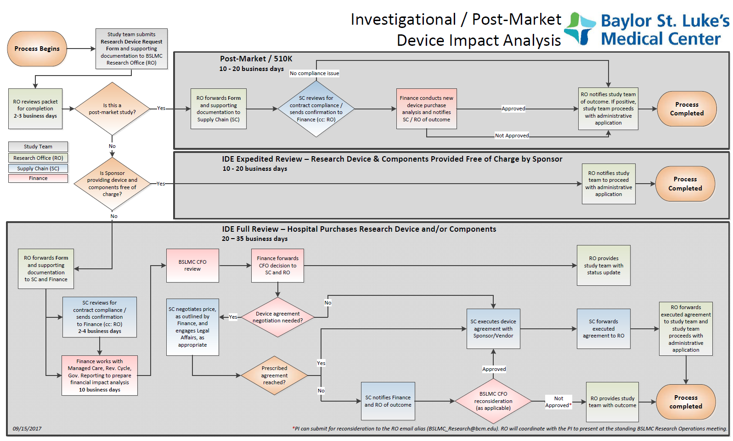

# Appendix VII

## BSLMC Epic Study Build

The below screenshots show the study information entered by the BSLMC Research Office when setting up your study in Epic, following administrative approval.

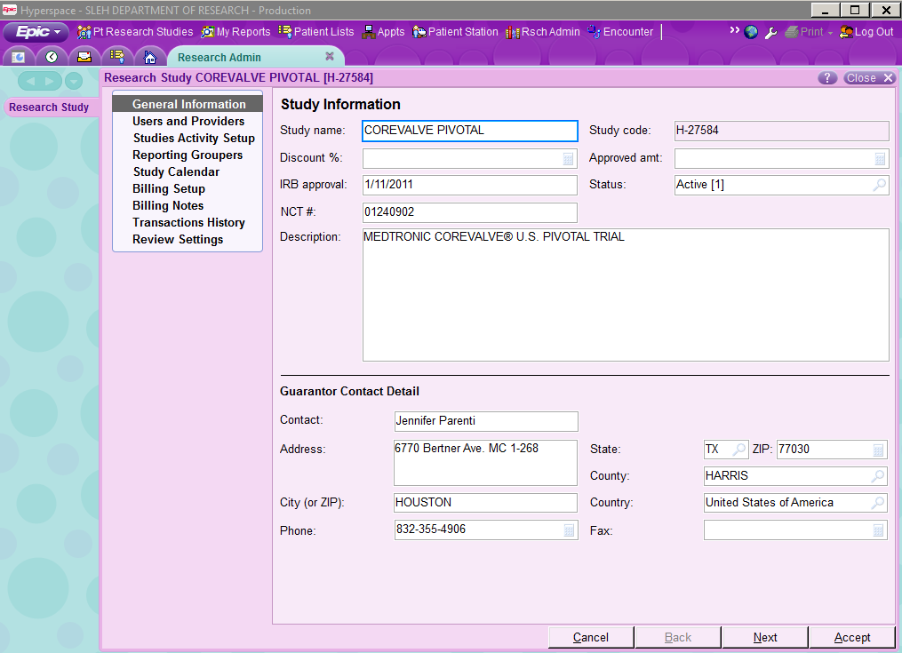

In Study Information, BSLMC enters general information about the study such as IRB#, study title, NCT#, IRB approval date, guarantor contact, and study status.

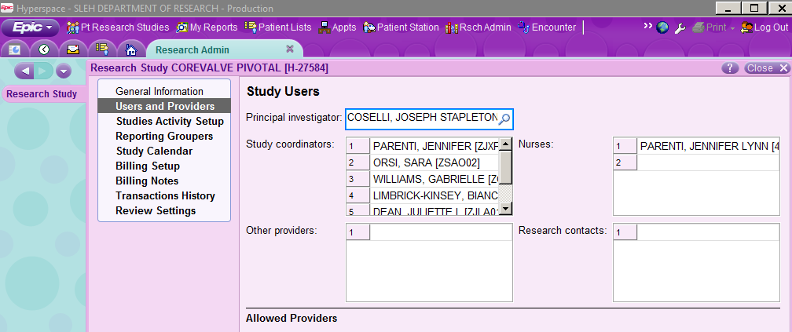

In Users & Providers, BSLMC Research Office enters the study personnel from the administrative application (PI, Co-PI’s, coordinators).

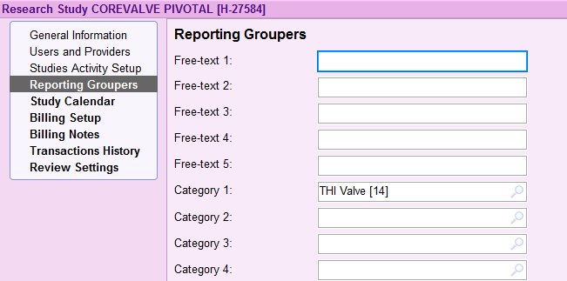

In Reporting Groupers, BSLMC Research Office assigns a recipient for reviewing research charges on the billing report

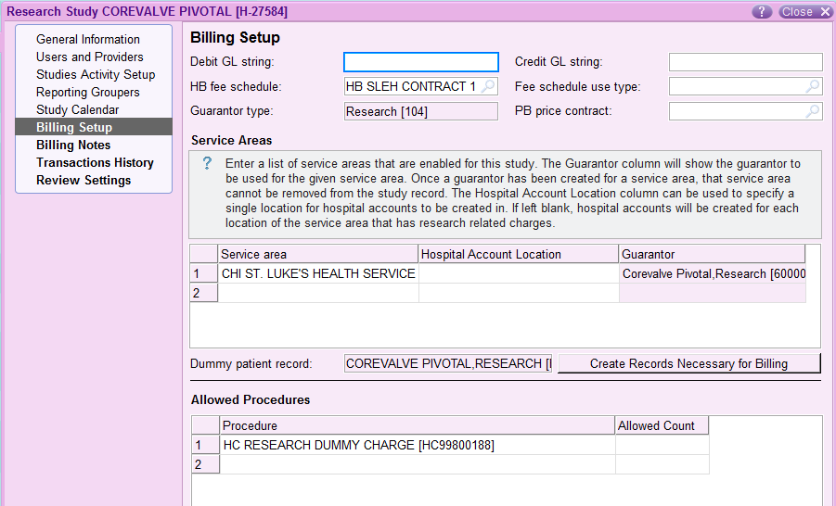

In Billing Setup, BSLMC Research Office assigns the service area, and a dummy charge to route charges to a research work queue.

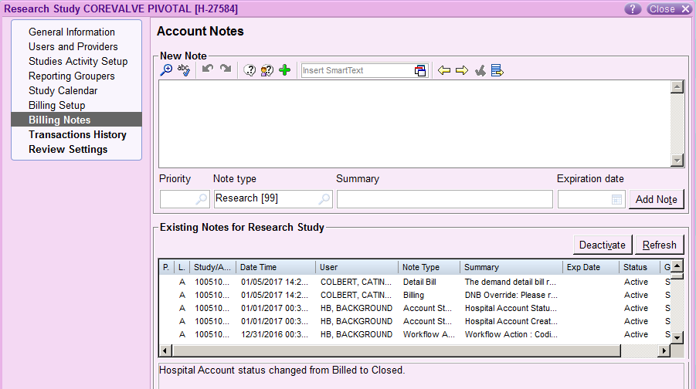

In Billing Notes, BSLMC Research Office adds any relevant financial notes for Patient Financial Services.

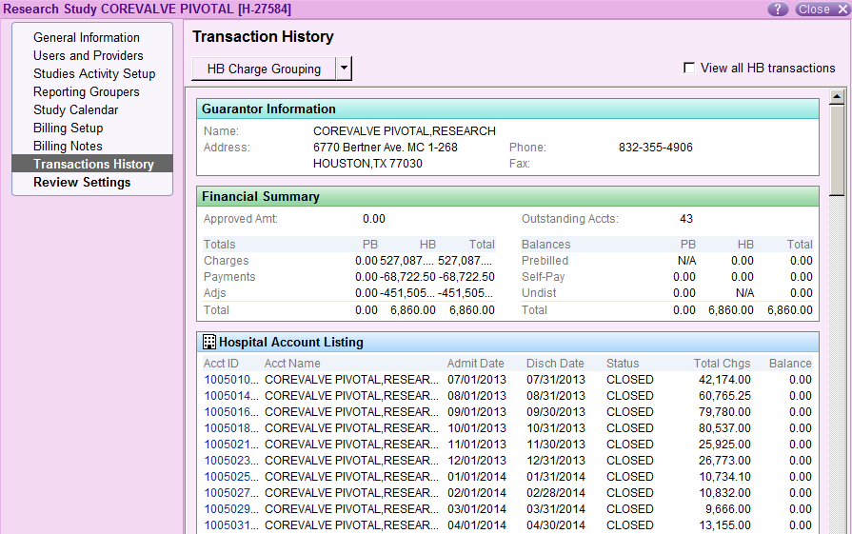

Transaction History shows a list of monthly charges for the study.